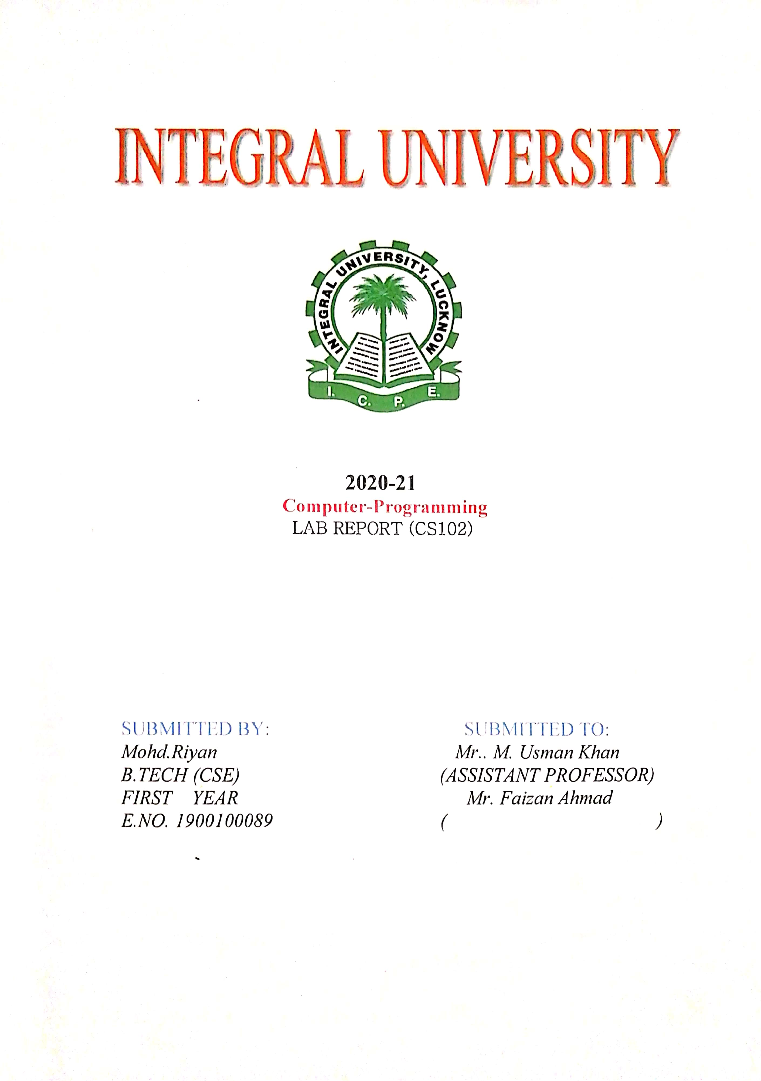

**2021-22**

**Microprocessor Lab Report**

**(CS-314)**

**SUBMITTED BY: SUBMITTED TO:**

**Mohd Riyan** **Mr. Badaruzzaman**

**B. TECH (CSE)**

**Group: CSE-2**

**3rd Year 6th Sem**

**E.NO. 1900100089**

**Roll.no 1901012131**

**ACKNOWLEDGEMENT**

I would like to acknowledge and extent my heartful gratitude to **Mr. Badaruzzaman** and …………………….under whose guidance I have prepare the **Microprocessor Lab.**

They have been a constant source of encouragement and inspiration to me.

I am also indebted to my batch mated who have been great help in the preparation of this Lab Report.

**NAME : MOHD RIYAN**

**EN.NO : 1900100089**

**CERTIFICATE**

This is to certify that **MOHD RIYAN** of **B. TECH** Third year has sincerely completed his **“ Microprocessor Lab”** & submitted it on time & has helped to maintain the decorum of LAB.

**Mr. Badaruzzaman ………………………….**

**INDEX**

|  |  |  |  |  |
| --- | --- | --- | --- | --- |
| **SL.NO** | **OBJECTIVE** | **DATE** | **REMARKS** | **SIGNATURE** |
| **1** | Write a program to two add 16-bit Hexadecimal numbers without carry |  |  |  |
| **2** | Write a program to two add 16-bit Hexadecimal numbers with carry |  |  |  |
| **3** | Write a program to find the greatest number from an array of 10 numbers |  |  |  |
| **4** | Write a program to calculate the factorial of a number |  |  |  |
| **5** | Write a program to multiply two 16-bit numbers result should be greater than 16-bit |  |  |  |
| **6** | Write a program to input 5 numbers and arrange them in descending order |  |  |  |
| **7** | Write a program to convert the string data it’s Two’s complement form |  |  |  |
| **8** | Write a program to read 8-bit data from Port B. Complement this data & send it back to Port A of |  |  |  |
| **9** | Write a program to move a block of data from one memory location to another |  |  |  |
| **10** | Write a program to find Gray code equivalent of a Binary number using Lookup Table |  |  |  |
| **11** |  |  |  |  |



**2021-22**

**Compiler Design Lab Report**

**(CS-316)**

**SUBMITTED BY: SUBMITTED TO:**

**Mohd Riyan Mr. Mohd Ishaq**

**B. TECH (CSE)**

**Group: CSE-2 ………………………….**

**3rd Year 6th Sem**

**E.NO. 1900100089**

**Roll.no 1901012131**

**ACKNOWLEDGEMENT**

I would like to acknowledge and extent my heartful gratitude to **Mohd Ishaq** and ……………………. under whose guidance I have prepare the **Compiler Design Lab Report.**

They have been a constant source of encouragement and inspiration to me.

I am also indebted to my batch mated who have been great help in the preparation of this Lab Report.

**NAME: MOHD RIYAN**

**EN.NO: 1900100089**

**CERTIFICATE**

This is to certify that **MOHD RIYAN** of **B. TECH** Third year has sincerely completed his **“Compiler Design Lab Report”** & submitted it on time & has helped to maintain the decorum of LAB.

**Mr. Mohd Ishaq …………………………….**

**INDEX**

|  |  |  |  |  |
| --- | --- | --- | --- | --- |
| **SL.NO** | **OBJECTIVE** | **DATE** | **REMARKS** | **SIGNATURE** |
| **1** | Write a program to perform matrix addition, matrix multiplication and check whether given string is palindrome or not, using case statements |  |  |  |
| **2** | Write a program to convert infix expression to postfix expression with the help of stack.  Write a program to convert infix expression to prefix expression with the help of stack |  |  |  |
| **3** | Write a program to check whether given string is constant or not.  Write a program to check whether given string is keyword or not.  Write a program to check whether given string is identifier or not |  |  |  |
| **4** | Write a program to implements Tokenizer for Lexical Analyzer. |  |  |  |
| **5** | Write a program to implement First of a grammar.  Write a program to implement Follow of a grammar. |  |  |  |
| **6** | Write a program to implement recursive decent parsing |  |  |  |
| **7** | Write a program to implement recursive decent parsing |  |  |  |
| **8** | Write a program to implement recursive decent parsing |  |  |  |
| **9** | Write a program to implement recursive decent parsing |  |  |  |
|  |  |  |  |  |



**2021-22**

**Computer Networks Lab Report**

**(CS-316)**

**SUBMITTED BY: SUBMITTED TO:**

**Mohd Riyan Mr. Amit Kumar Srivastava**

**B. TECH (CSE)**

**Group: CSE-2 …………………………….**

**3rd Year 6th Sem**

**E.NO. 1900100089**

**Roll.no 1901012131**

**ACKNOWLEDGEMENT**

I would like to acknowledge and extent my heartful gratitude to **Amit Kumar Srivastava** and **………………………….** under whose guidance I have prepare the **Computer Networks Lab Report.**

They have been a constant source of encouragement and inspiration to me.

I am also indebted to my batch mated who have been great help in the preparation of this Lab Report.

**NAME: MOHD RIYAN**

**EN.NO: 1900100089**

**CERTIFICATE**

This is to certify that **MOHD RIYAN** of **B. TECH** Third year has sincerely completed his **“Computer Networks Lab Report”** & submitted it on time & has helped to maintain the decorum of LAB.

**Amit Kumar Srivastava ………………………….**

**INDEX**

|  |  |  |  |  |
| --- | --- | --- | --- | --- |
| **SL.NO** | **OBJECTIVE** | **DATE** | **REMARKS** | **SIGNATURE** |
| **1** | Simulation of setting up basic router configuration. |  |  |  |
| **2** | Simulation of setting up of router name and password. |  |  |  |
| **3** | Simulation of setting up telnet |  |  |  |
| **4** | Simulation of setting up of Motd and login-banner |  |  |  |
| **5** | Simulation of setting up DHCP. |  |  |  |
| **6** | Simulation of setting up of static route configuration |  |  |  |
| **7** | Simulation of setting up Routing information protocol (Rip) |  |  |  |
| **8** |  |  |  |  |
| **9** |  |  |  |  |
| **10** |  |  |  |  |
| **11** |  |  |  |  |